Chapter 19, Solution 84

(a) Since A = and C = , we open-circuit the output port and let V₁ = 1 V. The schematic is as shown below. After simulation, we obtain

A = 1/V₂ = 1/0.7143 = 1.4

C = I₂/V₂ = 1.0/0.7143 = 1.4

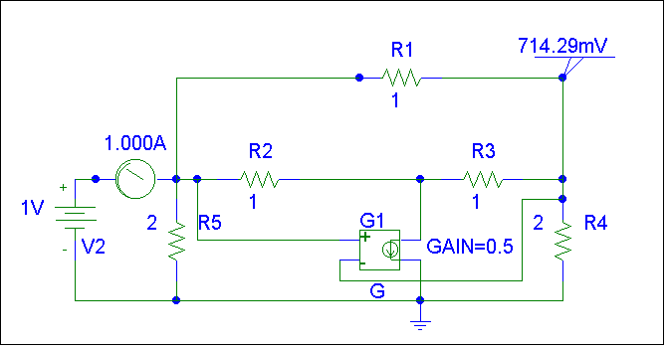

(b) To get B and D, we short-circuit the output port and let V₁ = 1. The schematic is shown below. After simulating the circuit, we obtain

B = –V₁/I₂ = –1/1.25 = –0.8

D = –I₁/I₂ = –2.25/1.25 = –1.8

Thus =

